INSTRUCTIONS

**Summary**

Over 5 rounds, you will be able to trade shares in an online marketplace. The traded share’s payoff equals the solution of a “knapsack problem”. This is a problem where one is asked to find the right items from a collection of possible items that fit a given knapsack while maximising its value.

During the experiment, you will have access to two websites and a spreadsheet. One website will be an online trading platform, and the other will be a platform where you can try out solutions to the knapsack problem at hand, to determine the highest value of the knapsack, and thus whether you should buy or sell shares. The spreadsheet will allow you to calculate the payoff per share for different knapsack values. You earn money by buying shares whose price is lower than the optimal value of the knapsack, and by selling shares whose price is higher than the optimal value of the knapsack. You will also earn a fixed $2 reward for each suggested solution you submit to the knapsack problem (independently of whether this solution is correct or not). After each trading round, you will be asked to answer a short question about your confidence in predicting your trading performance.

Following the completion of online trading (i.e., after all five rounds have been completed), you will be asked to answer a questionnaire. This questionnaire contains a series of interval-creation tasks, where you must respond to a general knowledge question with a numerical interval, such that you are 90% sure that the true answer to the question is contained within the interval.

At the end of the experiment, your earnings from trading will be determined by one randomly selected trading round. Your performance in each round will be equal to the sum of remaining cash and the payoffs from your final share holdings in that round, plus the reward for submitting a suggested solution to the Knapsack problem.

**Setting: Knapsack Problems**

In knapsack problems, one is given a list of items and asked to optimally load them in a knapsack. Each item has a *weight* and a *value*. The knapsack has a *weight limitation* that may prevent one from loading all items in the knapsack. Given this limitation, one is asked to determine the optimal load, i.e., the combination of items to be put in the knapsack that maximises its total value. The total value of a proposed knapsack equals the sum of the values of the individual items.

In each of the five rounds (plus a practice round) you can see the corresponding knapsack problem online*,* at <http://bmmlab.org/games>. You should use the Mozilla Firefox web browser to access this website (see Table 3). Log into the website with the ID and password you are given, and navigate to “Play Knapsack Game,” where you pick the problem corresponding to the market from the drop-down list (see Table 1 below for a list of problem identifiers). An example of the interface is shown in Figure 1 below. You will be asked to refresh this webpage and login again between each round, in order to navigate to the next problem.

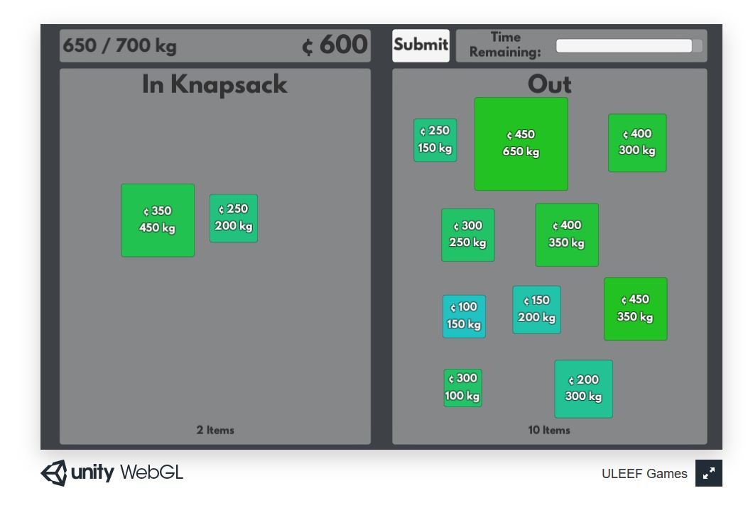

Figure 1: Knapsack Problem Interface

|  |  |  |
| --- | --- | --- |
| Round | Knapsack Problem Name | Market Name |
| Practice | KP-Practice | KPM-Practice |
| 1 | KP-Apple | KPM-Apple |
| 2 | KP-Banana | KPM-Banana |
| 3 | KP-Cherry | KPM-Cherry |
| 4 | KP-Durian | KPM-Durian |
| 5 | KP-Elderberry | KPM-Elderberry |

Table 1: Knapsack problem and market names

You can try for yourself which items you think should be in the knapsack, by moving the items you want in the knapsack in the “IN” panel, while keeping the others in the “OUT” panel (which is to the right in the above picture, but at other times will be to the left). Items are identified by their WEIGHT (their size increases with weight) and VALUE (their colour changes from blue to green as value increases). Before the round ends, you should SUBMIT your suggested solution by clicking on the “Submit” button. You only have to submit your solution as long as trading is open (see below). (There is a white bar next to the submit button which indicates “time remaining”; please ignore it.) You earn $2 when you submit your suggested solution, independent of whether it is correct or not.

**Important:** You are not allowed to access any webpages other than the two you are instructed to use (the knapsack problem and the market pages)! Failure to do so will lead to exclusion from the experiment.

**Earnings from Trading in the Online Market**

You can earn money by *trading in a market* where shares can be bought or sold. There will be only one type of traded shares. You will be able to determine the payoff per share through an online spreadsheet. You can enter any achieved knapsack value into the spreadsheet, which will then provide you with the corresponding payoff per share. Of course, whether this payoff equals the true payoff per share depends on whether you have entered the optimal knapsack value into the spreadsheet.

If you believe that shares are currently trading *above* the true share value, you can earn money by *selling* shares. In contrast, if you believe that shares are currently priced *below* their true value, you can earn money by *buying* shares. For example, if you think the optimal knapsack value is 1995 cents, and the spreadsheet tells you that the corresponding payoff per share is $12, you would prefer to buy shares priced below $12 and sell shares priced above $12. Note, you should enter knapsack values in cents into the spreadsheet.

Your total earnings from each trading round will consist of (i) the amount of final cash holdings, plus (ii) the sum of payoffs from each share that you hold at the end of trading.

At the end of the experiment, **one** round will be randomly selected as “payment round”. Your earnings from cash and shares will be converted into Australian dollars at a ratio of 2.5:1. So if, for example, you end up with 3 shares plus $14 cash, and the optimal knapsack value is $19.95 (1995 cents), then your payment in Australian dollars from that round will be equal to:

$[\left(12 * 3 shares\right)+14 cash]÷2.5=20.00 AUD$.

**Trading in the Online Market**

Trading takes place through an electronic trading platform called *Flex-E-Markets*. In *Flex-E-Markets* you submit *limit orders*, which are orders to buy or sell at a price you determine, or, if possible, at any better price. Transactions take place from the moment a buy order with a higher price crosses a sell order with a lower price. Orders remain valid until you cancel them or the marketplace closes. You will be given ample opportunity to train yourself in submitting and canceling orders.

You can access *Flex-E-Markets* as follows: use your logon information slip and log onto <https://adhocmarkets.com/> using the **ID labelled “Roused-Nipper”** , as well as the email on your information slip and the same password you have used to access the knapsack problem. You should use the Google Chrome web browser to access the online market (see Table 3). You should then navigate to the market name for the corresponding round (see Table 1 above for a list of market names). Each market will be open for a pre-determined time period (approximately 10 minutes). Instructors will notify you at halftime as well as one minute before markets close.

|  |  |  |
| --- | --- | --- |
|  | Website | Web Browser to use |
| Knapsack Problem | <http://bmmlab.org/games> | Firefox |
| Online Market | <https://adhocmarkets.com/> | Chrome |

Table 3: Websites to use and suggested Web Browsers

**Questionnaires**

After each round of trading, you will be asked to fill in the question sheet labelled *Questionnaire I*. These questions will ask you about the self-assessment of your trading performance in the previous trading round. After **all** rounds of trading have been completed, you will be asked to fill in the question sheet labelled *Questionnaire II,* which has three sections in total. The first section will ask you to answer ten general knowledge questions, whereas the second and third sections consist of a few follow-up questions.